**[About our Client – The Hyatt Regency Tokyo]**

The Hyatt Regency Tokyo is a historic luxury hotel located in the heart of Tokyo. With 700 renovated rooms and a refurbished lobby, it will undergo a complete transformation, expected to be completed around May 2025. In this rejuvenated environment, you can work in a wonderful setting, catering to guests from various countries. With the motto "Bring peace to those who arrive and happiness to those who depart," we all work together enthusiastically and harmoniously.

**Company Website:** <https://www.hyatt.com/en-US/hotel/japan/hyatt-regency-tokyo/tyoty>

**Address:** 2-7-2 Nishi-Shinjuku, Shinjuku-ku, Tokyo 160-0023

**[Requirement]**

The client is looking to hire **Kitchen** **Staff** in Japan under the SSW program. Given below are the detailed requirements and process:

|  |  |
| --- | --- |
| **Position** | Kitchen Staff |
| **Employment Type** | Full-time employee (*Probation period: 3 months) |
| **Gross Salary** | **Gross Salary: 226,500 yen per month**  *Separate overtime allowance, late -night allowance, early morning shift allowance, late -night allowance  ** The salary includes Meal Allowance (6,500 yen + taxes – approx 7,150 Yen per month and taxes and social insurance premium (approx 45,300 Yen Per Month)  **In Hand Salary (Gross Salary – Meal Allowance – Taxes & Social Insurance Premium): 174,050 yen per month** |
| **Salary Increment** | Once per year |
| **Bonus** | Twice per year (July and December) subject to satisfactory performance for up to 3 months of basic salary |
| **Job Responsibilities** | * Western cuisine cooking duties (Chef) at the restaurant or the banquet hall. * Chinese cuisine cooking duties (Chef) at the restaurant or the banquet hall. * Hygiene management/cleaning duties such as cleaning the kitchen and dishes etc. |
| **Number of Positions** | 5 (may hire more basis on the availability of suitable candidates) |
| **Workplace** | Tokyo |
| **Working Conditions** | * Monthly rotating work hours system (for example, 6:30 ~ 15:00, 8:00 ~ 16:30, 9:00 ~ 17:30, 10:00 ~ 18:30, 13:00 ~ 21:30, 14:30 ~ 23:00, etc. (including 1 hour break). Some sections may involve overnight shifts. * Annual Holidays: 123 days * Other: There are special vacations, congratulations, pre-childbirth leave, childcare leave, etc. |
| **Other Benefits** | * Insurance: Employees' Pension, Health Insurance, Employment Insurance, Workers' Compensation Insurance * Full reimbursement of transportation expenses (based on the company's designated commuting route) * Health checkups (twice a year) * Provision of uniforms and lockers * Employee cafeteria * Preferential rates for domestic and international stays at Hyatt hotels based on years of service. * Indoor smoking allowed (designated smoking booths available) * Internal training and correspondence education programs * Membership in the welfare club 'Lilo Club,' recognition system * Employee appreciation festival * Award System * Summer family party * Year-end-party * Employee recreation, etc. |
| **Desired Candidate Profile** | * Having strong communication skills and value teamwork. * Possess a curiosity towards new technologies and demonstrate a proactive attitude towards learning. * Can intuitively understand customer needs and find joy in fulfilling them. |

* Overall, the candidates have the potential of saving approximately INR 50,000/- to INR 70,000/- per month.
* The candidates can stay in Japan up to 5 years with possible further extension to stay for long term employment visibility.
* The candidates are allowed to switch jobs during their employment in Japan.

**[Eligibility Criteria]**

|  |  |
| --- | --- |
| Qualification | * **For candidates who are FRESHER with No experiences:**   + Graduated with a Hospitality Management diploma or degree and having exposure in working (Industry / OJT) in Kitchen area.   + Who are willing to learn Japanese Language full-time for approx. 9 months to pass the SSW related exams successfully to obtain the work visa) * **For Candidates who have experiences, we are expecting:**   + Candidates to have experience in Restaurant (or) in the Hotel Industry in working in Kitchen area.   + Who are willing to learn Japanese Language full-time for approx. 9 months to pass the SSW related exams successfully to obtain the work visa)   *\*The experience in Western or Chinese cuisines as such is not mandatory; however candidate must be familiar with Cooking and Kitchen activities.* |
| Age | 20 ~ 27 Years |
| Gender | Any |
| English Requirement | Good |
| Documents Requirement | * Aadhar Card * Education qualification certificates * Hotel Management Degree * Work experience certificate (if applicable) * Passport |

**[Process]**

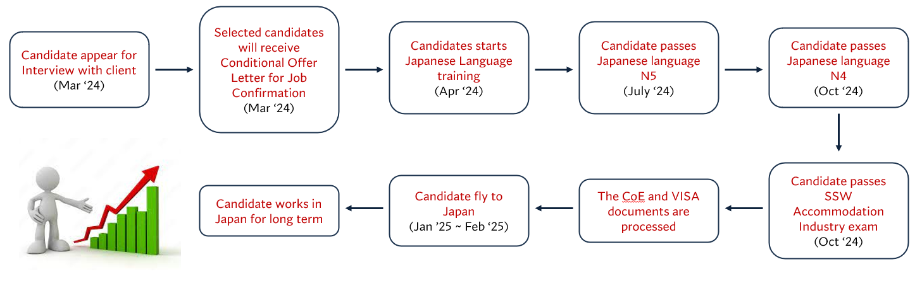

**[Interview & Training]**

1. Interview Location – Delhi
2. Interview Dates – 27th to 29th March 2024
3. The selected candidates will undergo full time paid Japanese language training for 9 months by NSDCI in identified location (Gurugram / Dehradun / Hyderabad / Varanasi).
4. Regular interaction with Japanese natives for better exposure.
5. The candidate must pass Japanese Language Exams and SSW Skill Exams as per the schedule.
6. No Recruitment Fees are to be paid by the candidate. Only Japanese Language training fees is being charged.
7. The SSW industry test is currently not available in India. In case, the test doesn’t start till the candidates are ready, the client will bear one time cost of travel to another country to appear for the test.

**[Fee for the Candidates]**

|  |  |  |
| --- | --- | --- |
| **Particulars** | **Amount (INR)** | **Remarks** |
| Japanese Language Training Fees | INR 75,000/- | * INR 10,000/- Before Interview (to be returned fully if the candidate is not selected in the interview) * INR 15,000/- On Starting the Training Program * INR 20,000/- On Passing N5 Exam * INR 30,000/- After receiving the CoE   *Skill Loan to be provided for candidates, as per the requirement. |
| Exam Fees – Japanese Language & SSW Exam | approx INR 7,000/- | To be paid directly to the exam bodies |
| Medical Exam Fees | approx INR 5,000/- | To be paid directly to the medical exam center |
| VISA Fees | approx INR 2,500/- | To be paid directly to the Embassy |
| Boarding & Lodging | To be managed by the candidates | |

* The above-mentioned amount is exclusive of GST.
* The flight tickets will be paid by the company (in exceptional scenario, the client doesn’t provide the flight ticket then the candidate may have to bear the cost)