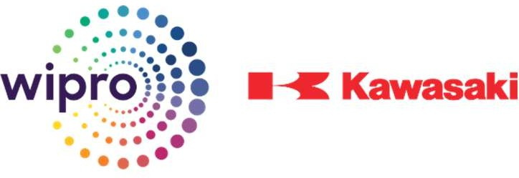

Job Description

|  |  |
| --- | --- |
| **Trainee Title:** | **DIPLOMA ENGINEER TRAINEE - Age Group - 18-22**  **Looking for only 2024 or pursuing eligible passed out candidates.** |
| **Business Unit & Locations :** | **Wipro Kawasaki Precision Machinery Pvt. Ltd. ,**  **1. Kumbalgodu, Bangalore 2 Bidadi, Bangalore** |
| **Reporting to:** | **Production Supervisor & Production Engineer, Plant Incharge** |
| **Stipend CTC/PM & Other Benefits** | **CTC of 2.51 lacs p.m. take home of Rs. 16,500/- including quarterly Bonus & Attendance Incentive – Other benefits PF, ESI, Free Transportation & Food** |
| **Job Profile:**   1. **Induction Period:** Fresh candidates will be inducted into the company to work and gain skills over a period of one year. Willing to work in all 3 shifts 2. **On-the-Job Training:** During this period, trainees will receive practical "On the Job" training. This means they will learn by actively participating in the company's operations. 3. **Core Work Practices:** Trainees will gain insights into the fundamental work practices carried out on the shop floor. This includes understanding how the company's manufacturing processes work. 4. **Technical Knowledge:** The training program aims to equip trainees with technical knowledge, particularly in areas such as machining, turning, and assembling of hydraulic pumps and swing motors and in other functions as well. 5. **Skills Enhancement:** Trainees will work on enhancing their skill sets, which means they'll become proficient in the tasks and techniques relevant to their roles in the company. 6. **Product Process Flow:** Trainees will gain "hands-on experience" in understanding how products move through the production process. This involves learning about the sequence of steps and stages a product goes through from raw materials to the finished product. 7. **Japanese Concepts:** The training program may also introduce trainees to Japanese concepts related to manufacturing. This could include principles such as Kaizen (continuous improvement), 5S (a workplace organization method), and other methods commonly associated with Japanese manufacturing practices.   In summary, this briefing describes a comprehensive training program that integrates practical on- the-job experience. The goal is to prepare fresh candidates for their roles within the company by giving them a deep understanding of the manufacturing process and enhancing their technical skills. | |
| **Skills and Knowledge required:**   * Only Fresher can gain this industry ready skill sets | |
| **Educational Qualification:**   * Fresher’s - Diploma in Mechanical Engineering, Machine Tool Technology. | |